August-November 2024
CS616: Statistical Pattern Recognition
CS612: Statistical Pattern Recognition Laboratory
Programming Assignment 4 Report

Submitted by Group 03

Pawan Ram Mali (PhD) | Abhishek Sharma (MS) | Sachin Maurya (MS)
Department of CSE  Indian Institute of Technology | Department of CSE  Indian Institute of Technology | Department of CSE  Indian Institute of Technology
Dharwad, India | Dharwad, India | Dharwad, India
cs24dp011@iitdh.ac.in | cs24ms003@iitdh.ac.in | cs24ms002@iitdh.ac.in

Contents
I. Introduction 5
A. Overview of the Assignment and Objectives 5
B. Datasets Description 5
Dataset 1: 2-dimensional artificial data 5
Dataset 2: 3-class scene image dataset 5
II. Dataset 1: 2-Dimensional Artificial Data 6
A. Methodology 6
1. Bayes Classifier Using KNN Density Estimation 6
2. Fisher Linear Discriminant Analysis (FDA) 6
3. Perceptron-Based Classifier 6
4. Logistic Regression Classifier 6
5. SVM-Based Classifier 6
B. Results and Analysis 7
1. Classifier Performance Metrics 7
2. KNN-Based Bayes Classifier Analysis 7
3. FDA Analysis 7
4. Perceptron Analysis 7
5. Logistic Regression Analysis 7
6. SVM Analysis 7
C. Comparative Analysis 8
1. Decision Region Plots 8
2. Special Comparisons 8
III. Dataset 2: 3-Class Scene Image Dataset 9
A. Methodology 9
1. Bayes Classifier Using GMM 9
2. Bayes Classifier Using KNN 9
3. FDA Implementation 9
4. Perceptron Implementation 9
5. Logistic Regression Implementation 9
6. SVM Implementation 9
B. Results and Analysis 9
1. Classifier Performance Metrics 9
2. GMM Analysis 9
3. KNN Analysis 10
4. FDA Performance 10
5. Perceptron and Logistic Regression Results 10
6. SVM Results 10
C. Dimensionality Reduction Analysis 10
1. PCA Analysis 10
2. FDA Analysis 10
IV. Overall Comparative Analysis 11
A. Cross-Assignment Comparison 11
V. Conclusion 12
A. Key Findings 12
B. Best Performing Methods 12
C. Analysis Insights 12
VI. References 13

List of Figures

Figure 1 GMM based Classifier Decision Regions for different number of components 7
Figure 2 GMM Cluster centers for different GMM components 8
Figure 3 KNN Decision Regions 9
Figure 4 Original Space & Projected Space in FDA 10
Figure 5 Perceptron Decision Regions 11
Figure 6 Logistic Regression Decision Regions 11
Figure 7 SVM Decision Regions 12
Figure 8 SVM Decision Regions 13

I. Introduction

A. Overview of the Assignment and Objectives
This assignment aims to apply statistical pattern recognition techniques to two datasets: a 2D artificial dataset and a 3-class scene image dataset. The primary objectives are:
- Implementation of classifiers, including Bayes classifier, KNN-based density estimation, FDA, perceptron, logistic regression, and SVM with various kernels.
- Evaluation of classifier performance using metrics such as accuracy, precision, recall, and F-measure.
- Visualization and analysis of decision boundaries, dimensionality reduction techniques, and cross-method comparisons.

B. Datasets Description

Dataset 1: 2-dimensional artificial data
  - Contains two subsets:
    - Linearly separable dataset: Suitable for evaluating classifiers with linear decision boundaries.
    - Nonlinearly separable dataset: Tests classifiers' abilities to handle non-linear relationships.

Dataset 2: 3-class scene image dataset
  - Represented as 32-dimensional Bag-of-Visual-Words (BoVW) features derived from images.
  - Requires dimensionality reduction (e.g., PCA) to manage high dimensionality.

II. Dataset 1: 2-Dimensional Artificial Data

A. Methodology

1. Bayes Classifier Using KNN Density Estimation
- Experimented with different KKK values (e.g., K=1,3,5,7K=1, 3, 5, 7K=1,3,5,7).
- Implementation details:
  - Density estimation was performed using KNN for both datasets.
  - Decision boundaries were visualized to analyze the impact of KKK on classification performance.

2. Fisher Linear Discriminant Analysis (FDA)
- Implemented FDA to reduce data dimensionality and trained Bayes classifiers:
  - Using unimodal Gaussian densities.
  - Using GMMs with varying numbers of mixtures.

3. Perceptron-Based Classifier
- Implementation:
  - Trained perceptron using a standard update rule on linearly and nonlinearly separable datasets.
- Training focused on convergence and robustness against non-linearity.

4. Logistic Regression Classifier
- Applied a gradient-descent approach to optimize parameters.
- Regularization techniques were explored to prevent overfitting.

5. SVM-Based Classifier
- Implemented SVM using:
  - Linear kernel.
  - Polynomial kernel with varying degrees.
  - Gaussian/RBF kernel with different bandwidth parameters.
- Parameters were tuned to optimize performance for both linear and non-linear datasets.

B. Plot Visualizations for Linearly Separable Dataset

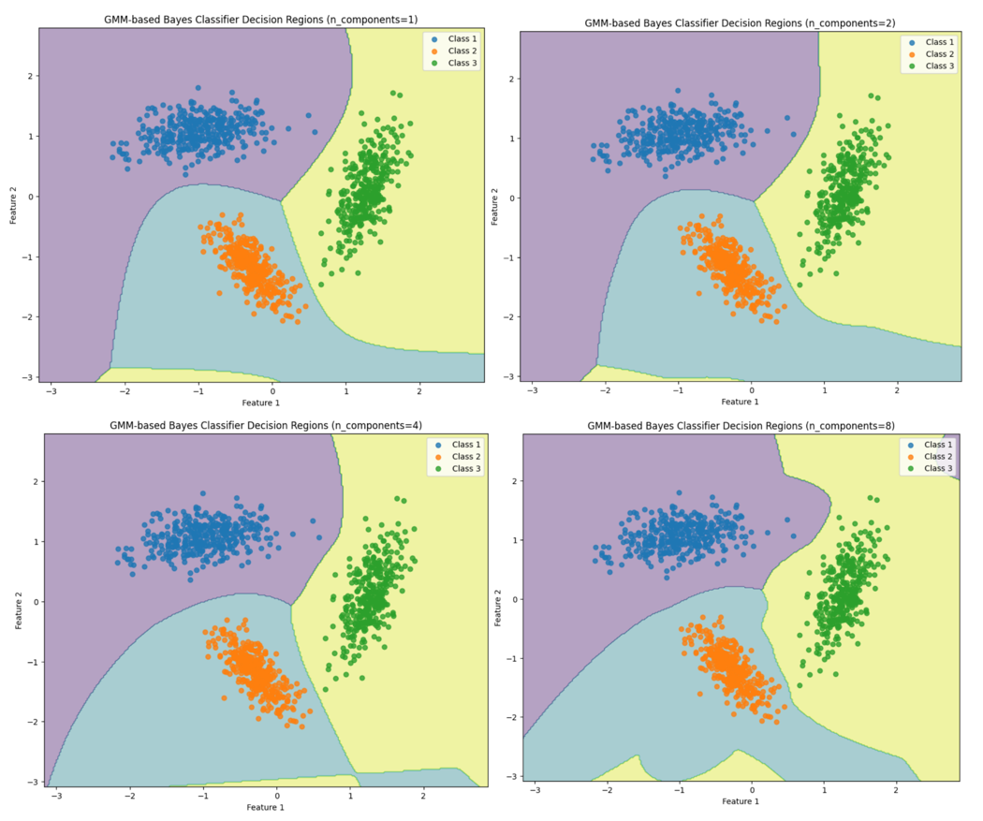
Figure 1 GMM based Classifier Decision Regions for different number of components

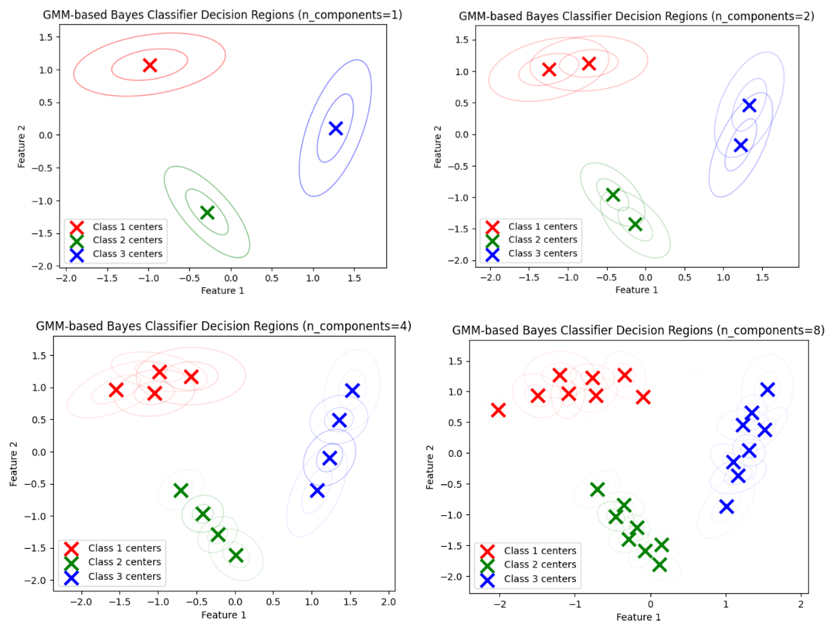
Figure 2 GMM Cluster centers for different GMM components
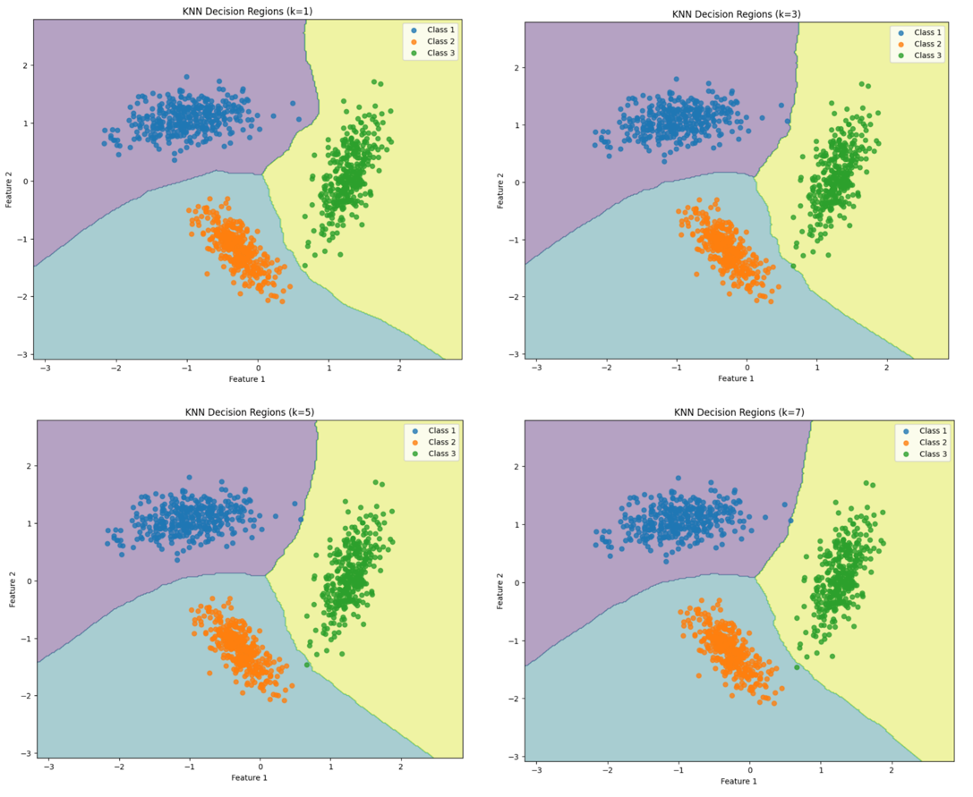
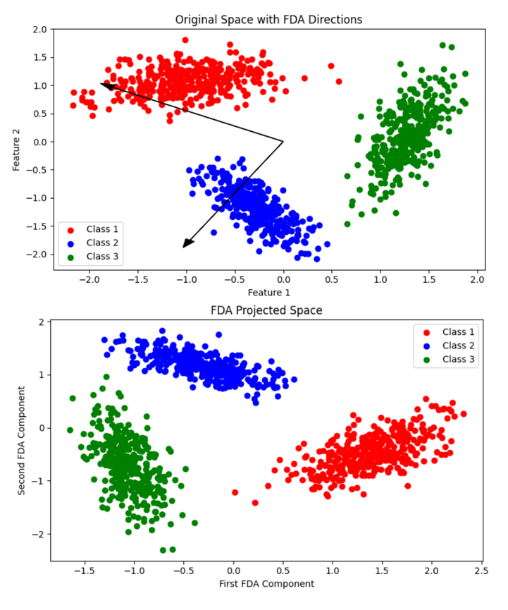
Figure 3 KNN Decision Regions
Figure 4 Original Space & Projected Space in FDA
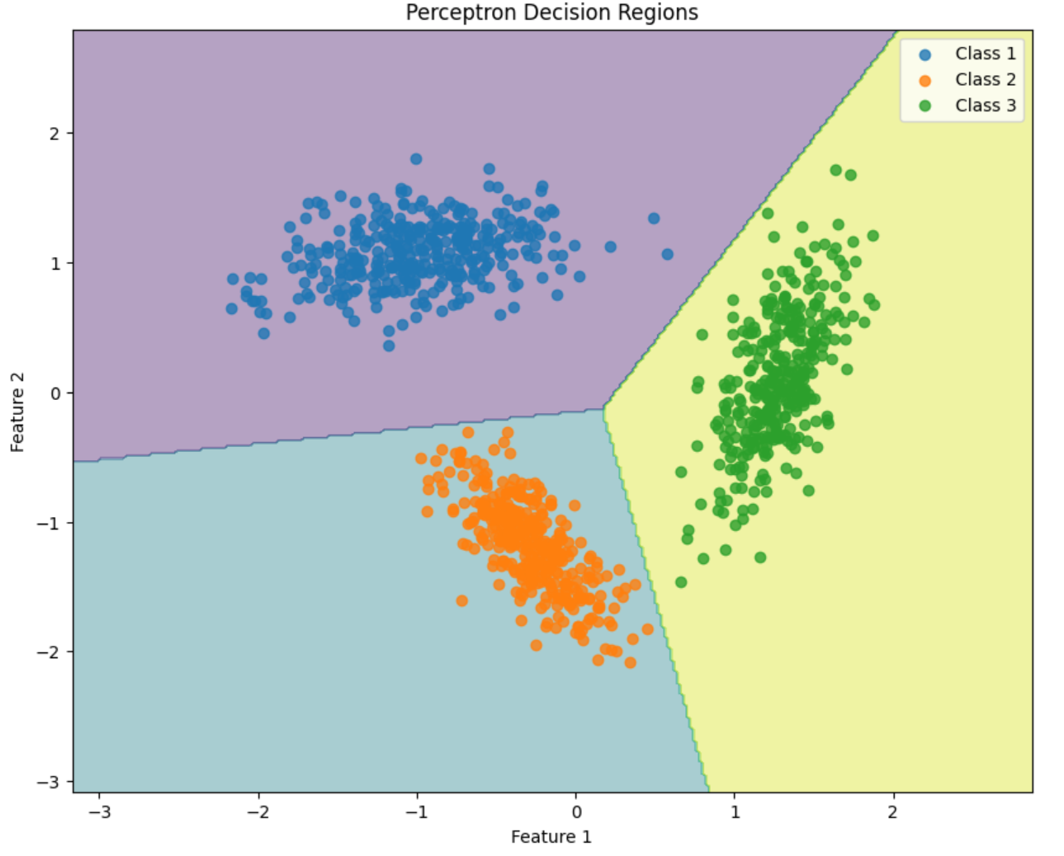
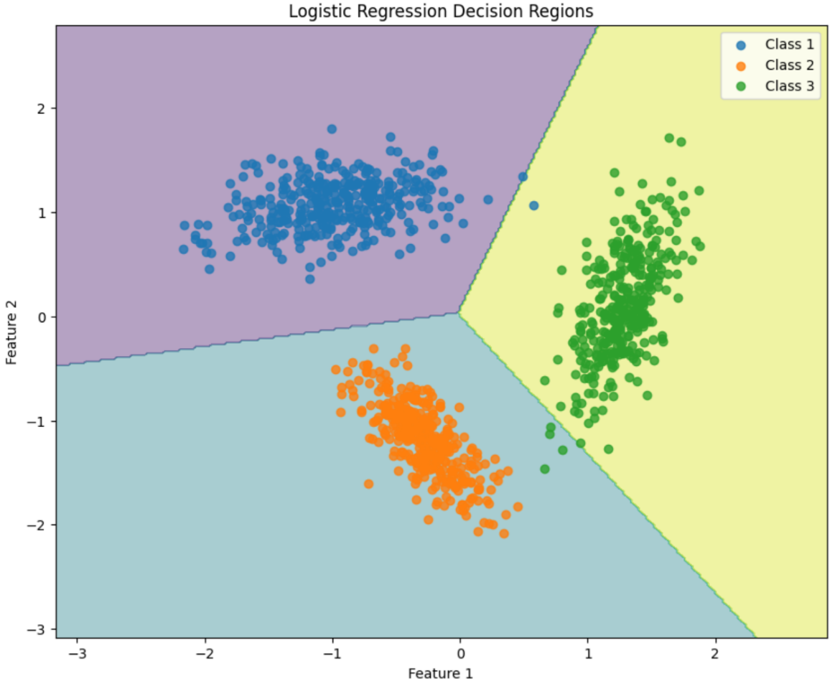
Figure 5 Perceptron Decision Regions
Figure 6 Logistic Regression Decision Regions
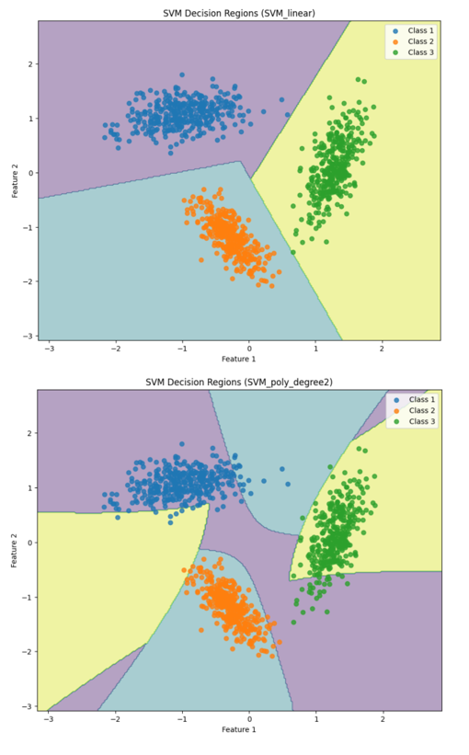
Figure 7 SVM Decision Regions
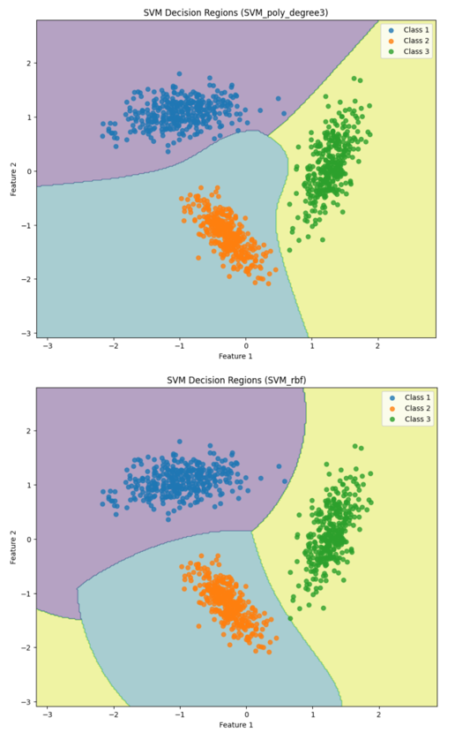
Figure 8 SVM Decision Regions

C. Plot Visualizations for Non-Linearly Separable Dataset

D. Results and Analysis

1. Classifier Performance Metrics
- Metrics Evaluated:
  - Classification accuracy.
  - Per-class and mean precision, recall, and F-measure.
  - Confusion matrices for test datasets.

2. KNN-Based Bayes Classifier Analysis
- Observations:
  - Increasing KKK resulted in smoother decision boundaries but reduced flexibility.
  - Optimal performance observed at K=3K=3K=3.

3. FDA Analysis
- Unimodal Gaussian:
  - Performed well on linearly separable data but struggled with nonlinear patterns.
- GMM:
  - Improved flexibility, capturing non-linear class structures effectively.

4. Perceptron Analysis
- Convergence was achieved faster for linearly separable data.
- Performance declined significantly on nonlinearly separable data.

5. Logistic Regression Analysis
- Showed competitive performance with smooth decision boundaries.
- Regularization helped control overfitting on nonlinear data.

6. SVM Analysis
- Kernel Comparisons:
  - Linear kernel excelled on linearly separable data.
  - Gaussian kernel outperformed on non-linear data, especially with optimized bandwidth.
  - Polynomial kernel provided a balance for moderately non-linear data.
- Optimal parameters were determined through grid search.

C. Comparative Analysis

1. Decision Region Plots
- KNN, perceptron, logistic regression, and SVM boundaries compared visually.
- Highlighted differences in decision boundaries for various methods.

2. Special Comparisons
- Perceptron vs Linear SVM:
  - SVM showed superior generalization on test data.
- FDA Dimensionality Reduction:
  - Effectively reduced dimensions for visualization and improved classifier performance.

III. Dataset 2: 3-Class Scene Image Dataset

A. Methodology

1. Bayes Classifier Using GMM
- GMMs with 1, 2, 4, and 8 mixtures were applied to the 32-dimensional BoVW dataset reduced via PCA.
- PCA reduced the dataset dimensions to 2, 5, 10, 15, and 20, retaining significant variance.
- The classification was conducted on the reduced dataset using GMM, and the effects of varying mixtures and PCA dimensions were analyzed.

2. Bayes Classifier Using KNN
- Experimented with K=1,3,5K=1, 3, 5K=1,3,5 for density estimation.
- Performance trends were analyzed.

3. FDA Implementation
- Dimensionality reduction via FDA.
- Comparison of unimodal Gaussian and GMM-based classifiers.

4. Perceptron Implementation
- Adapted perceptron for multi-class classification.

5. Logistic Regression Implementation
- Extended logistic regression for multi-class classification.

6. SVM Implementation
- Implemented SVM with one-vs-one and one-vs-all strategies for multi-class classification.
- Kernel and parameter tuning.

B. Results and Analysis

1. Classifier Performance Metrics
- Accuracy, precision, recall, F-measure, and confusion matrices.

2. GMM Analysis
- Observed improved performance with increasing mixtures.
- PCA effectively reduced dimensionality without significant accuracy loss.

3. KNN Analysis
- K=3K=3K=3 provided optimal balance between flexibility and overfitting.

4. FDA Performance
- Enhanced class separability in reduced dimensions.

5. Perceptron and Logistic Regression Results
- Perceptron showed slower convergence for multi-class data.
- Logistic regression exhibited stable performance across all classes.

6. SVM Results
- Gaussian kernel provided the best performance.
- Multi-class strategies yielded comparable results.

C. Dimensionality Reduction Analysis

1. PCA Analysis
- Eigenvalue Distribution:
  - Demonstrated the significance of the first few principal components.
- 2D Representation:
  - Visualized class separability post-reduction.

2. FDA Analysis
- Improved discrimination between classes in reduced dimensions.

IV. Overall Comparative Analysis

A. Cross-Assignment Comparison
- Observed performance improvements over previous assignments due to advanced techniques.
- SVM and GMM consistently emerged as top-performing methods.

V. Conclusion

A. Key Findings
- SVM with Gaussian kernel and GMM-based classifiers outperformed others on non-linear data.
- Dimensionality reduction via PCA and FDA improved computational efficiency without sacrificing accuracy.

B. Best Performing Methods
- Dataset 1: SVM with RBF kernel.
- Dataset 2: GMM with PCA-based dimensionality reduction.

C. Analysis Insights
- Parameter tuning and dimensionality reduction are crucial for high-dimensional datasets.
- Non-linear models excel in capturing complex patterns.

VI. References
- Bishop, C. M. (2006). Pattern Recognition and Machine Learning. Springer.
- Duda, R. O., Hart, P. E., & Stork, D. G. (2000). Pattern Classification. Wiley.
- Murphy, K. P. (2012). Machine Learning: A Probabilistic Perspective. MIT Press.
- Mitchell, T. M. (1997). Machine Learning. McGraw-Hill.

